HR DIRECTORS BOARDROOM

Leeds 2019

Building High Performance During Uncertainty and Ambiguity

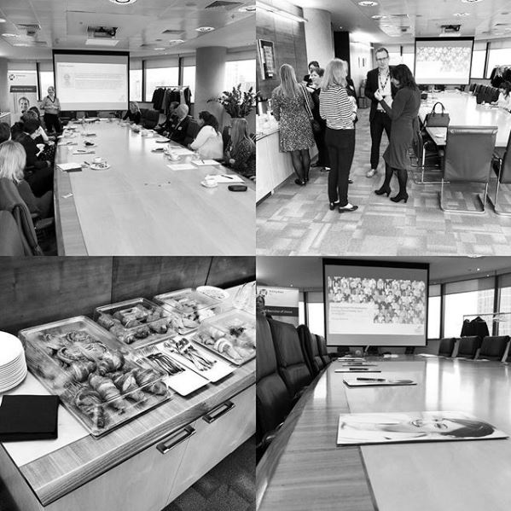

elegates gathered at Eversheds Sutherlands (International) LLP and participated in this thought provoking and informative boardroom event. Introduced by Karen Brown – Senior Business Manager and Cameron Davies, HR Recruitment Consultant for Ashley Kate HR & Finance and chaired by Helen Rice-Birchall, Principal Associate.

Tracey Jackson, Head of HR for Legal and General Modular Homes led the morning to give us her insight into this well discussed topic, but with an interesting twist based on Tracey’s wealth of experience. Tracey took us on a whistle stop tour of her career, explaining that she has been lucky enough to work for a broad spectrum of businesses. However, she has been delighted to find herself working for a start-up business, which benefits from the backing of a large, successful organisation. Here, change is now a state of life and whilst this produces many opportunities it is not without its challenges.

Legal and General Modular Homes will be used as a case study for the discussion for the morning – but Tracey was keen to share ideas and experiences with all delegates.
With any start up there are high and lows, the highs are the freedom, the opportunity and the chance to create something new that is really good, the lows are that many people “don’t get it” and people do not feel knitted together. So it is vital that this is a real focus area for HR – to knit people together in addition to everything else!
So, the focus on High Performance, this is not new, but in such circumstances a new perspective is required. A key part of Tracey’s focus was mind set. We are all creatures of habit, it is human nature and especially in an environment such as start-up it is so important to look to influence this. The example Tracey used to bring this point home was learning a new language. If we were deserted in a foreign country, with no support, we would learn the language because we absolutely needed to. If we have a choice to learn and it is not so essential, then we take longer to do this, or indeed don’t do it! Clearly, we are not being limited by our capability to learn, but by ourselves and our mind set. This point needs to be at the forefront of your mind, when your board or your operatives won’t think differently – it is difficult for them to do this, it doesn’t come naturally and you need to take this into account.
Two volunteers were called for, two people nervously agreed and they were tasked with throwing a ball between them. To begin with, this was slow and rather awkward, after a few throws this speeded up and a rhythm was found. This is because both brains were taking in lots of factors, the size and shape of the ball, the speed, the other thrower, not wanting to fail to name a few. However, very quickly the volunteers were able to achieve success. This is the same for our workforce, they are weighing up a lot of factors from a lot places, and this will be in addition to preconceived ideas – especially with regard to what success is. This means that you need to support that to get to that comfortable position.
This exercise highlighted the need for a compelling vision. Everyone remembers Martin Luther King “I have a dream”, if this had been “I have an idea, but I’m not sure about it” his following and results from it would have been very different!
Carol Dweck, highlighted the difference between a growth mind set and a fixed mind set and this will seriously affect how open individuals are to new ideas and also their fear of failure. You need a real goal, a reason to change and motivate you to accept a new idea, without this you are likely to fail. This is why so many New Year’s resolutions fail and fail so quickly. This again needs to be at the forefront of your mind when you trying to convince your workforce, you need to give them that compelling vision and the will, desire and motivation to change.

Then another great picture for us to remind us of how to grow. The lobster! The lobster has to shed it’s shell to enable it to continue to grow, but this obviously leaves it very vulnerable, but this is essential to growing – as it is with us and your workforce. Tracey also reminded us that it can be a real positive to demonstrate vulnerability, but most people are uncomfortable with it.
So what do we need this compelling vision to be? Fundamentally it needs to be realistic for many reasons. The vision needs to be opened up – just facts and figures are not enough for the vast majority of people.
At L & G Modular Homes they are applying science to HR in the same way that marketing has done in recent times. They categorise all employees so that they can ensure that they truly understand them. Tracey did expand on the fact that this was possible given the start-up nature of the business and also the overall size. Bit by doing this can understand their employees mindsets and also how best to influence this.
But Tracey was very clear that working with L & G Modular Homes was about High Performance and if not then you would not be staying. It has taken a while to agree what this needs to look like and hasn’t been a comfortable journey. However, they now have a very clear road map and operate through a very open culture, which with a headcount of 150 is easier to facilitate and drive then a much larger workforce. Employees are encouraged to challenge and this is in a safe and secure culture, again supported by the size of the organisation.
This culture is reflective of what the business is looking to achieve in the market, it is challenging the norm, modular housing is still relatively new and flies in the face of traditional house building.
Everyone agreed that this was a great discussion and some very useful examples to bring the key messages home.

Our exclusive HR Directors Boardroom discussion gives you unprecedented access to valuable business and professional contacts as well as providing you with unique opportunities to debate topical and strategic HR issues. We have dates in place for 2019 for the debates and well as essential Employment Law Updates.

Please email hrnetworking@ashleykatehr.com to find out more or to book your place.

Website | Twitter | Facebook | YouTube | Instagram
Copyright © 2019 Ashley Kate HR Ltd, All rights reserved.

