HR DIRECTORS BOARDROOM

London 2018
Entrepreneurial HR – How HR can Transform their business

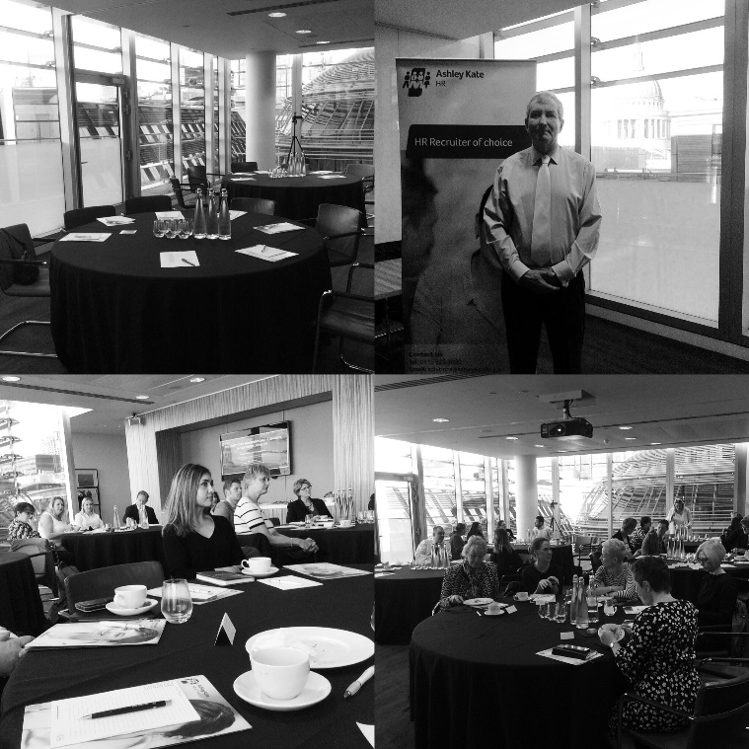

elegates gathered at Eversheds Sutherlands (International) LLP and participated in this thought provoking and informative boardroom event. Introduced by Kate Ryder, Senior Recruitment Consultant and Karen Brown – Senior Business Manager for Ashley Kate HR & Finance and chaired by Paul Fonte – Partner and Head of Employment London – Eversheds Sutherland (International) LLP.
Chris Roebuck led the event, and gave us a great insight into his take on how Entrepreneurial HR needs to be next step on the journey from the HRBP and the positive and very real impact that this can have on a business.
With over 35 years in senior roles, including HR, Chris now utilises his experience to work with leaders across the globe to inspire and focus them on transforming their businesses through their people. Chris has been quoted as a business leadership expert globally in the Harvard Business Review China, FT, Wall Street Journal and many other titles. He has also been recognised as one of the Most Influential HR Thinkers regularly since 2010 by the HR profession. So we were all keen to hear Chris’s view on HR and the journey needs to take.
Chris’s focus for HR is on relevance, resonance, results and ROI, which utilises his experience from large corporates to SME’s and from the world of economics to the army.

Everyone is familiar with the HRBP model, but the question was posed, was this ever meant to be the end goal? This is now 20 years old, and with all organisations needing to become more agile and entrepreneurial, HR needs to not just follow suit but lead the way.
So why is this currently not happening in the majority of instances? Many reasons where discussed but the key ones highlighted are:
  - Capability shortfalls
  - Reactive not proactive
  - Just doing what the clients wants – not focusing on strategic goals
  - Assumed not real need – too much focus on the symptoms not the cause
  - Inappropriate solutions – not delivering “best current outcome” but focusing on “inappropriate best practice”
  - Ineffective positioning / selling – not effectively selling a compelling vision
The above are really critical in affecting the role that HR can play in an organisation, with many senior leadership teams unaware of whet HR can offer and the value that it can drive.
So how do HR professionals overcome these issues? Fully understanding your business is critical to success, and Chris threw this question out, to the HRD’s in the room, how many truly understood their business and probably more importantly do their teams. Many progressive HR departments, can say that they do, and felt supported by and valued by the board. However, many felt that their teams understanding could be better and needed to be a focus moving forward.
Chris then demonstrated that the shortfalls of many HR teams is not to focus on the end customer need. Even when this is recognised as a shortfall, it is often the last area to focus on, when, in fact, it should be the first. In Chris’s experience this is often the biggest shortfall. A simple tool for this would be to get your teams to complete a simple SWOT on the business and then build on this.
Once this knowledge improves, aligning work to the strategic goals of the organisations becomes clearer and easier. When you consider that studies show that 25% of work completed by managers is not aligned to strategic goals, the knock on effect with a largely reactive HR team is that much time is spent on work that is not tied into the strategic objectives.
Another key issue is that many businesses are still not aware of the value that HR can add. There is also a very real issues around the ongoing conflict and confusion between line managers and HR over who should do what. This sounds simple, but is a constant and real issue, with each role often opting to stay in their comfort zones. This not only has the result of keeping HR firming in the “administrative” “process” role, but limits the development of managers and leaders. Another simple exercise which has been utilised by Chris over the years is to compile a list of factors such as performance management, dealing with conflict and give the same list to line managers and to HR.

Delegates may not be surprised to know that many items are seen as the responsibility of the other! But without this clarity, the status quo continues.
So what should the HR Entrepreneur be focused on:
  - Understanding the “now” world better
  - Improving the “now” world – improve efficiency and impact, prioritise work of strategic benefit and deeply understand how success happens
  - Then proactively build the future
Chris is passionate about HR being a catalyst for success and with his economic and financial background, this relates to profit and the risk of potential lost profit. Indeed investors do assess key areas where HR should be focused, such as:
  - Competent leaders – at all levels
  - Clear vision and strategy with everyone aligning their work to this
  - Optimised collaboration and entrepreneurial leadership
HR should not be waiting to be asked, they should be identifying what could be improved and suggest action to deliver. In too many businesses HR are still seen as peripheral and reactive and this needs to change. Many in the room still saw the negative effects of a lack of understanding of what HR can do, as HR has been seen as too focused on best practice and not best outcome. Thus leading a business down a road where it is seen as focused on policy, procedure and admin and then leaders and managers see HR as preventing entrepreneurial leadership rather than leading it.
Sometimes this lack of understanding is due to previous experience, but also to how HR position themselves and their value. HR are not often natural “sales” people, but the positioning of their value and impact is critical.
The discussion then started to focus on the impact within the business of focusing on your managers and really understanding what makes a great manager and how to develop this as a priority. Whilst this all sounds like common sense and something that all HR teams will be involved in to a degree – Chris was able to refocus our thoughts onto what should be obvious, but often forgotten, in the throws of management and leadership courses.
We were all asked to think of a time when we had a great boss, one that enabled us to do our best. The list produced by the room was reflective of the ones that Chris has seen for many years and included:
Empowered, trust, caring, listened, encouraged, challenged, gave time, curious, inclusive, decisive.

What always comes up is that the emotional relationship with your manager is much more important than the task relationship. And in addition, all the factors that we rate highly ourselves, are known by managers and are free! So, we just need to ensure that our managers are focused on the right factors to inspire and motivate their teams – and this simple exercise is another great tool to do this. In general this is being done, we just need to do more of it.
In order to support this, quite simplistic approach, Chris took us through some basic psychology as to why this works. It is worth remembering that we are all wired to reciprocate, so if someone does something you that is positive, you respond positively, they then view this as positive and react positively! And the circles continues. Unfortunately, the same is true in reverse.
A quote from Aristotle, shows that whilst our businesses have changed and continue to change beyond all recognition, how our brain works hasn’t “pleasure in the job puts perfection in the work”
From basic psychology to facts and figures – Chris has collated the compelling statistics below that quantify the effort difference between line managers who do and don’t:
  - Tell people what they do contributes to the bigger picture +28%
  - Fair and accurate feedback day to day +39%
  - Showing employees you genuinely care +25%
  - Line manager impact 17 of the top 20 drivers of high performance
So what prevents this from happening? Chris then asked us to think about the % of initiatives that we have seen or been involved in and how many of these had been implemented successfully. The consensus in the room was between 30% – 40%, the norm for this is 25% - 35%. This clearly demonstrated the amount of wasted time and effort on “new” initiatives that never land, or add value. Indeed, they take focus and time away from the areas that can make a fundamental difference.
The question of time was a challenge to Chris, as whilst managers know they need to do these things, they simply don’t have the time. Chris brought us back to the time wasted on work not connected to the strategic goals and to unsuccessful initiatives – but also the thought, how can you afford not to!
Chris concluded the morning with some words of advice for all leaders from his time at Sandhurst, when your people look at you they will ask two questions of you:
  - Do you know what you are doing?
  - Do I trust you?
If the answer to both of these is yes, these people will do their best for you and if necessary die for you. In our organisations the latter is fortunately not required, but it is imperative that you and your managers can get the best from people and this is where your focus needs to be.

The key message from Chris is that HR is not being as commercial and entrepreneurial as it easily could be with a clear focus on specific areas of understanding and simple actions. In addition HR has the capability to enable significantly better organisational performance through enabling leaders to get the best from people and focus that onto what delivers success. Again, this can be delivered not through complex HR initiatives but by simple day to day actions which most leaders already know but need help to leverage more effectively. In the end it’s about keeping it simple and focusing on what really makes a difference – in other words optimises ROI.
Chris is available to brief boards and leadership teams on his inspiring approach to leadership which he does around the world. This has been instrumental in a number of organisations taking forward HR proposals around leadership, high performance and culture change by presenting a compelling case for HR to take the lead as a catalyst for success.
Chris book – “Lead to Succeed” is an instruction manual for both leaders and HR who want to enable their organisations to become world class in all aspects of their performance. Both hard and electronic copies are available from Chris via : CLICK

Website | Twitter | Facebook | YouTube | Instagram
Copyright © 2017 Ashley Kate HR Ltd, All rights reserved.

Our exclusive HR Directors Boardroom debates gives you unprecedented access to valuable business and professional contacts as well as providing you with unique opportunities to debate topical and strategic HR issues. We have dates in place for 2018 for the debates and well as essential Employment Law Updates.

Please email hrnetworking@ashleykatehr.com to find out more or to book your place.

