HR DIRECTORS BOARDROOM

Cambridge 2018

The Future of HR

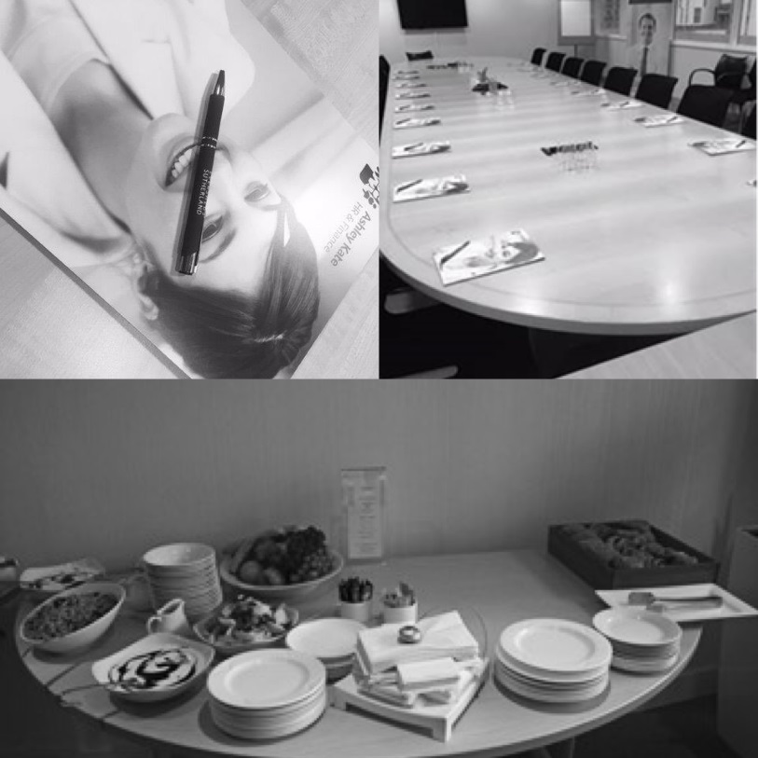
elegates gathered at Eversheds Sutherlands (International) LLP and participated in this thought provoking and informative boardroom event. Introduced by Karen Brown – Senior Business Manager for Ashley Kate HR & Finance and chaired by Simon Tytherleigh, Partner Eversheds Sutherland (International) LLP.

Karen Sanders led the event, and gave us a great insight into her thoughts on the future of HR and the key areas of change and what she feels this important profession needs to focus on moving forward.
To start with, and focus us all Karen played a video called Did You Know.
Did You Know?
This, very markedly, demonstrated the speed of change and the impact that this has on all our lives, and very much on all our working lives.
Karen explained that she spoke on this very topic ten years ago and the one area that she underestimated at the time was the pace of change. As the video clip demonstrated, the pace of change has grown exponentially, and I suspect no one would have anticipated quite how fast this would be. This is primarily driven through technological changes, and the speed of this change. We

did discuss how the video could be viewed, as some will see this as very worrying whilst others would see it has a wonderful opportunity.
Technology needs to be seen as wonderful opportunity, it allows us all to work more efficiently, to take away the more mundane and enable a focus on a real value adds.
So why is it so important that HR are looking to the future? As a business critical improvement function, HR need to be leading and implementing a workforce strategy to future proof the business. And for this to succeed the leaders of the business need to be innovative, embrace change, be agile and ensure that they take timely action when required.
As the famous quote from Darwin tells us, “It’s not the strongest of the species that survives, nor the most intelligent, but the most responsive to change”
Karen used one simple example of how, in line with all these changes, there needs to be a fundamental mindset change on so many factors. How do you view a CV, especially one where someone has had various roles for reasonably short periods of time? This is becoming the norm and is likely to continue, we need to rethink how we look at such things.
So what did Karen see as the key challenges for HR?
The advancement of technology (whilst an opportunity, this is also a challenge)
Demographic, political, social or physical changes
Global, social mobility
Internal forces, structure changes
Accidental, constant or specific change
Customer base – market analysis and future markets
So just a few! Karen then moved on to pitch the ‘C’ word versus the ‘P’ word. A question on where the focus for HR should be – on Culture or Policies, Procedures and Practices.
Karen took us through an interesting journey of the focuses for HR from the distant past, current past and the way forward. This clearly demonstrated the move away from policy and administration being the focus of HR to a greater focus on being a change agent, technical expert to a catalyst of change and an equal partner with all business leaders.
A large part of Karen’s HR future was talking about “Tomorrow’s People” and how the look and expectations of the current and future workforce are very different and how HR professionals need to embrace this and to challenge other leaders who resist changes to reflect this, such as job design and flexibility.

To end with a word of advice from Karen, with all the focus on the shape of future workforces and technological advances, don’t loose sight of your “likeability” factor. HR need to be able to influence and to be heard, especially at the top table, and if you need to break away from the norm, you need to be credible and have that likeability factor so that your voice is heard and people listen.
Karen Sanders is an experienced HRD with over 20 years’ experience in both the public and private sector, working at executive levels Karen is also a very active CIPD member, who speaks regularly on a variety of key HR topics.

Website | Twitter | Facebook | YouTube | Instagram
Copyright © 2017 Ashley Kate HR & Finance Ltd, All rights reserved.

Our exclusive HR Directors Boardroom debates gives you unprecedented access to valuable business and professional contacts as well as providing you with unique opportunities to debate topical and strategic HR issues. We have dates in place for 2019 for the debates and well as essential Employment Law Updates.

Please email hrnetworking@ashleykatehr.com to find out more or to book your place.

